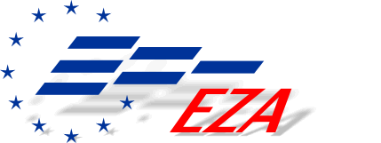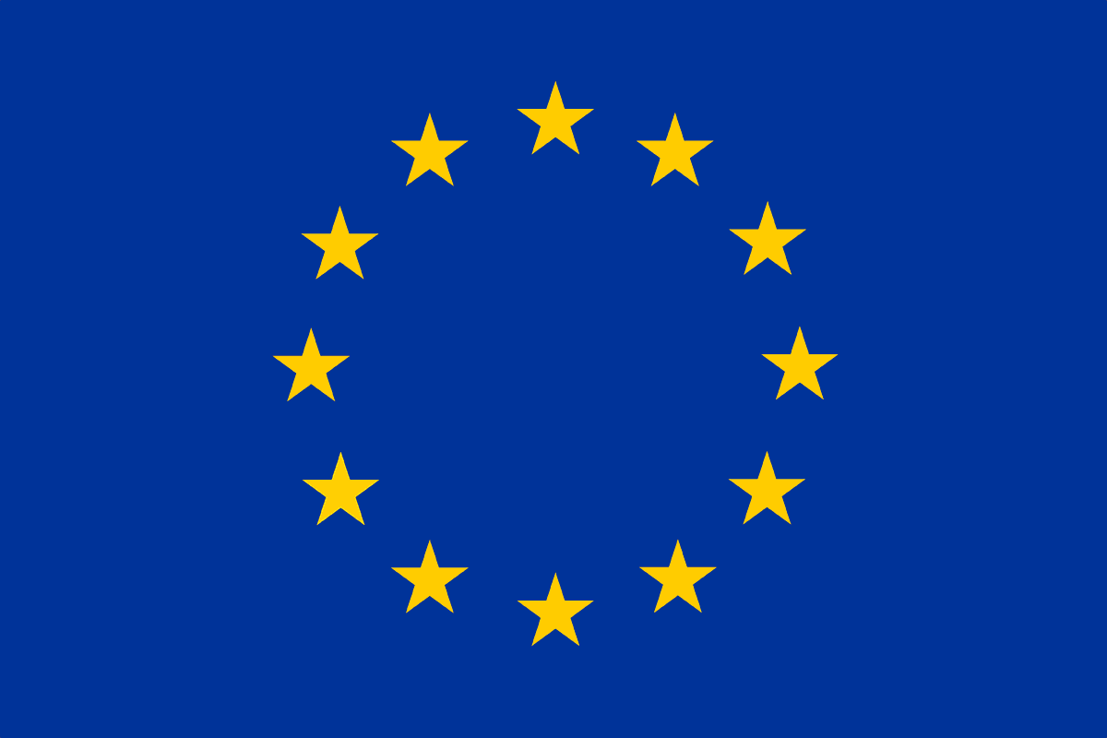

International seminar

THE ROLE OF SOCIAL PARTNERS IN DEFINING A CONSTRUCTIVE MODEL OF LABOUR RELATIONS FOR DECENT AND SUSTAINABLE QUALITY JOBS

June 2-4, 2015

RESOLUTIONS
ON THE CRISIS OF THE SOCIAL DIALOGUE IN LITHUANIA

The participants of the international seminar by the Lithuanian Trade Union Solidarumas,

Affirming the failure by the Lithuanian government to ensure an effective social dialogue among social partners in the process of reforming the labour relations, and its efforts to diminish the role of the social partners in the Tripartite Council of the Republic of Lithuania in addressing economic and social issues of importance for country’s employees;
Recalling the Country Report Lithuania published by the European Commission services on 26.2.2016, outlining that social mechanisms remain weak in the country, collective agreements hardly play a role, and only a minority of employees are covered by such agreements;
Recalling The Global Competitiveness Report 2015-2016 by the World Economic Forum where Lithuania is ranked 72nd in labour-employer cooperation;
Affirming that the Social Dialogue is a key pillar of the Europe’s social model comprehensively acknowledged by the Treaty of Amsterdam amending the Treaty of the European Union;
Reiterating that, by ratifying the European Social Charter, Lithuania has committed to encourage labour-employer consultations and seek to effectively ensure their rights to collective bargaining,
Affirm that the Social Dialogue between social partners in Lithuania is weak, while the scope of bargaining, or a share of employees covered by collective agreements on wages, constitutes about 8 per cent of all entitled employees;
Urge the Lithuanian Government to encourage the dialogue between the social partners, respect their autonomy and take all appropriate measures to facilitate the dialogue by ensuring equivalent support to parties.

On the new Labour Code and the social model
Currently, the Seimas is discussing the new Labour Code and other associated draft laws of high importance for all employees, individuals of retirement age and parents raising families.
We encourage the members of Seimas to vote responsibly on each article of the Labour Code and remember that their decisions would have effects for interests of certain groups of citizens.
We oppose the plans of the Labour Code authors to reduce the influence of and guarantees for trade unions. Our concern is that representation of employees would be abolished, as fragile traditions of social dialogue could pass away in Lithuania. Following the abolition of the Secretariat of the Tripartite Council two years ago, the current efforts to reform the Council can turn it into an insignificant body.
Members of Solidarumas are under a bad pressure from their employers to quit trade unions in recent time. Invited one by one, employees are pressurised to sign a membership cancellation statement in return for improving labour conditions or a higher salary. It creates unhealthy environment in and divides labour communities. The mission of trade unions is to seek for common representation and conclude collective agreements on behalf of all workers. Artificially created works councils do not fulfil their functions; neither do they care about employees’ concerns.
Lithuanian Trade Union Solidarumas proposes: to amend the Law on Public Tenders so that bidding companies are obliged to have trade unions and have signed collective agreements.
Expected to boost employment, new types of labour contracts deserve a special focus, since they will push employees into working for very low salaries and facilitate shadow businesses. As many as 300 thousand workers earn less than a minimum wage today. However, higher salaries would increase employees’ contributions to the social security system and help to raise pensions that are very low now for the prevailing majority of the retired.
The effects of the new Labour Code on women’s life and their opportunities to balance their work and family obligations are an important concern.
Bearing in mind the demographic problems, we demand to protect the motherhood to ensure respect to women and proper conditions for raising new Lithuanian citizens.
Seminar participants believe that the new liberal Labour Code could only be good for a young, well-educated, smart, fit, and family-free worker. However, we do not see this as a normal priority among values of the democratic state that would ensure an operational society.
Emigration, corruption, working poor phenomenon, inequality, and other systemic problems of Lithuania are all consequences of a bad governance in public finance. Labour taxation in Lithuania constitutes 55 per cent of the net salary, one of the highest levels in Europe. It puts the heaviest burden on honest workers, while capital’s billions stay untaxed. Workers have to pay alone for dealing with pressing social needs of the state.
State policies must focus on measures to increase income of Lithuanian workers. Ongoing advanced learning should be a priority for such policies, including the new Labour Code.

Regarding the National Agreement on Wage Policies
Having analysed the experiences of other countries at the international EZA seminar, Lithuanian Trade Union Solidarumas stands against proposals of the International Monetary Fund (IMF) to refrain from increasing the minimum monthly wage (MMW). IMF’s justification that the salaries grow higher that the labour productivity this year ignores the fact that labour productivity kept growing well ahead of the salary growth for years. With wages increased, as a rule, for well-paid company bosses only, corporate profits returned to the pre-crisis level and reached 19 per cent last year, as statistics indicate. It shows that Lithuanian companies are capable of reinstating the wages harshly cut during the crisis.
Scandalously, the Lithuanian GDP per capita constitutes 75 per cent of the EU average, while the average salary in Lithuania is just twice as little, reaching 45 per cent of the EU average. It denies allegations that the lower labour productivity justifies lower salaries in Lithuania. Though GDP per capita in Lithuania is higher than in Estonia (73 per cent) and Latvia (64 per cent), the MMW in Lithuania (350 euro) is below 360 euro in Latvia and well below 430 euro in Estonia. Among the highest in the EU, the social exclusion in Lithuania is still growing. Lithuania is the European leader in emigration per capita. It creates a grave threat to the sustainability and the future of the entire economy of Lithuania. Therefore, we call on the Lithuanian Government to abide with recommendations of the EU Commission on the MMW, introduced in the report on 20 February, and to fulfil commitments to increase the minimum monthly wage. The report indicated that “minimum wage growth is expected to have a positive impact on consumption by minimum wage recipients and hence on economic growth”. MMW should constitute 60 per cent of the average wage level. As Solidarumas supports effective and transparent wage policies, we suggest signing by social partners the National Agreement on increasing salaries to all workers in Lithuania. Minimum wage should be paid only for an unskilled work. Social partnership is crucial for implementing this provision.
ON DIGITAL REVOLUTION
The participants of the international EZA seminar affirm that the emerging global digital revolution is introducing multiple changes to the labour market, with new jobs and industries appearing and others disappearing. As these changes will affect all countries and industries, they also create a new challenge for Lithuania.
The digital revolution might destroy jobs in Lithuania, with new hundreds of thousands emigrants having to leave, or create new well-paid jobs and increase the competitiveness of Lithuania in the world. It will depend on the manner how the government and businesses manage to transform the economy, the organisation of work, social policy and education systems to function in the new reality.
The social partners and the government are equally interested in these changes bringing positive results; therefore, we urge to reinforce the social dialogue at the national, industry and company levels. Cooperation between the social partners and the government is crucial to ensure successful reforms of the labour market, social security and education systems, so that the digital revolution-affected workers feel secure and enjoy timely advanced training and retraining measures, labour market newcomers are ready for new challenges, while Lithuania as a whole gets closer to the European standards of living.
ON SOCIAL SAFEGUARDS
Lithuania belongs to a group of EU member states with the lowest tax collection and a disproportionate share of shadow incomes. Many employees tend to accept a part of their income as an ‘envelope wage’ at the expense of their future pension without feeling mistreated by their employer. The situation would change if Sodra, the Lithuanian social security fund, followed the practice of many European countries to accumulate money at a personal employee’s account with a clear link to the amount of the future retirement benefit.
Workers should be encouraged to come back from private pension funds to Sodra. In contrary to public Sodra, private pension funds are unsafe and can go bankrupt together with all savings. Private pension funds weaken Sodra by taking money from it and forcing to borrow more. Money paid by Lithuanian citizens to private pension funds leave Lithuania and do not work for our economy. We have to follow the example of Hungary and pass a law on an obligatory choice between Sodra and private pension funds, something that retook a major bulk of Hungarians back to the public social security system. Sodra must be merged with the state budget.
These measures could improve the financial situation of the Lithuanian social security, and increase social benefits and pensions without additional costs.
Resolution on posted workers and equal rights
The European Union rests on four freedoms, the free movement of people, goods, capital, and services. The freedoms enable employees from one EU member state to go for work to another one without a special work permit, while employers, in their turn, can provide services without barriers. Enshrined in the EU legislation, the free movement of services justifies the practice of posting workers abroad for service provision.
As a rule, workers get posted for service provision to other EU countries as a cheap labour force; this is a way for foreign employers to save costs on wages that are several times higher in old EU member states than in Lithuania.
Some companies in Lithuania are established for doing nothing more but hiring people and posting them to work in other EU member states. Lithuanian firms serve as a cheap sub-contractor for foreign companies.
Therefore, the posted workers earn several or even ten times less than local employees, though performing the same work. We can refer to an example of long-haul truckers. As a rule, their labour contracts provide for a minimum wage, a basis for all taxes and future social benefits, and an opportunity to cut the per diem rate by up to a half. In the same time, local drivers of the same country earn 2,000 to 3,000 euro.
In addition, long-haul trucking services are particularly notorious for salary and per diem payments in cash, and a variety of per diem deductions; in some cases, the amount of salary paid in accordance with the labour contract is deducted from the due per diem amount.
The above-mentioned facts call for a need to:
- amend the Ordinance of the Government of the Republic of Lithuania #1365 ‘On the Amount and Payment Procedures for Costs of Official Business Trips’ and abolish the possibility to cut the per diem rate by 50 per cent;
- introduce mandatory bank payments for per diems and salaries;
- ensure at the state level that the posted workers are entitled to the minimum wage of the host country. While some EU member states, such as Germany, France and Norway, have such a provision in their legislation, it is not enforced in practice. incorporate the Posted Workers Directive into the Lithuanian legislation to ensure the same salaries to posted workers as to local workers in destination countries.
Resolution on joining forces of trade unions
The delegates of the 15th Congress of the Lithuanian Trade Union Solidarumas, mindful of:
- the social environment in the country, whereas the liberalisation of labour relations entrench upon social provisions for workers and a minimum level of certainty in lives of Lithuanian citizens;
- pre-conditions being created for even more unsafe and unreliable terms for youth employment;
- the social dialogue being rather a formality, while employees of both public and private sectors avoid real cooperation with trade unions or signing collective agreements both at a company and an industry level;
- the still prevailing disrespectful or even degrading attitude towards workers;
- the increasing capital’s pressure on workers and their organisations, amid the growing social exclusion around the globe,

affirm that Lithuania is in a bad need for strong trade unions and a strong national trade union centre more than ever.
We emphasise that the dehumanised economic policies of our state and a lack of focus on social capital clearly indicate a need for trade union leaders to put aside divisions, ambitions, beliefs, and personal agendas, and to agree on common values, goals and activities. Therefore, we call upon all trade unions and their leaders to seat down together at a round table and start developing a consolidation strategy as soon as possible.

Resolution on collective sectoral rate agreements

The Congress of the Lithuanian Trade Union Solidarumas regrets the fact that employer – trade union bargaining on collective sectoral rate agreements during the last quarter of the century was fragmented and Lithuania still has no collective sectoral rate agreements with wage differentiation, in contrast to our neighbouring Nordic states.
By refusing negotiations on sectoral or regional collective agreements, employers neglect democratic values, and facilitate dishonest and non-transparent conduct of business.
Rather than stuck at the minimum level, wages should be differentiated to reflect the work contribution, responsibility, skills, and loyalty to the profession. The worker’s salary must guarantee an opportunity to have rest, take care of health and self-development.
The Congress of Solidarumas strongly recommends the Government and the Seimas of the Republic of Lithuania to pass appropriate pieces of legislation and other legal acts to encourage the actual conclusion of collective agreements by provision of the socially responsible company status to companies and other groups, with appropriate guarantees and preferences;
as a guaranty of reliability and quality of contractors or suppliers, to establish a condition by the Law on Public Tenders for bidders to have a working collective agreement reviewed by regional or sectoral trade unions;
the Law on Competition must contain an assessment of fair practices; the fact that a company has no collective agreement and is in disputes internally or externally with its competitors should be seen as a dishonest competition (unfair practices), with appropriate sanctions for dishonest conduct of business, infringing interests of honest companies, and unfair profits;
to apply measures by current or newly adopted pieces of legislation to exert influence on bargaining and signing collective agreements, something that would ensure a better quality of goods, professional service-provision, decent salaries and other payments, living and working standards to all citizens of and other people living in Lithuania.

Chairperson Kristina Krupavičienė

